Experiment 2
Aim:
To design a user interface that allows users to recall visual elements such as icons or text chunks and evaluate how chunking improves memory recall.
Introduction
Chunking is a cognitive psychology technique where information is grouped into smaller meaningful units, making it easier for the brain to process and remember. In user interface design, chunking helps organize visual information effectively, allowing users to recall elements more easily. This experiment demonstrates a UI where users view grouped visual elements for a short duration and then attempt to recall them. The effectiveness of chunking is evaluated through a recall task.
UI Design Screens
The interface consists of four main screens designed in Figma to simulate the memory recall experiment.
- Instruction Screen
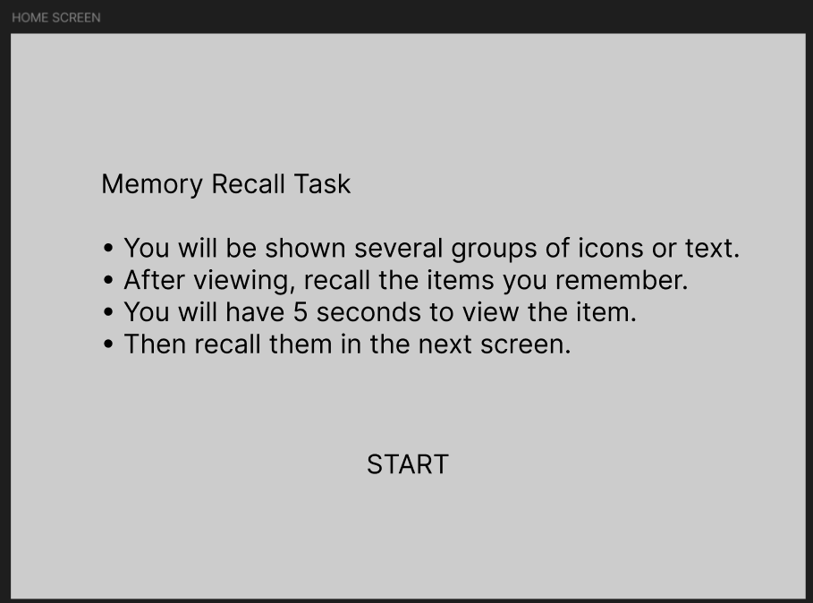
Instruction Screen:
The instruction screen introduces the task to the user.
Features
• Displays the title “Visual Memory Recall Using Chunking.”
• Provides clear instructions explaining the memory task.

• Users are informed that they will see groups of icons for 5 seconds.
• After viewing, they must recall the items in the next screen.
• A Start button is provided to begin the experiment.
Purpose
This screen prepares the user and ensures they understand the task before proceeding.
2. Chunking Screen
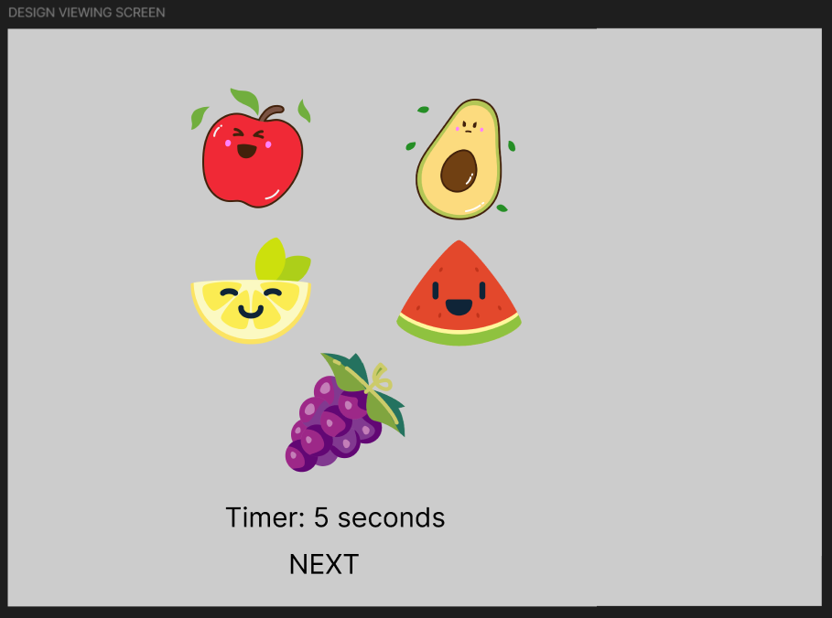
Chunking Screen:
This screen displays grouped visual elements that the user must remember.
Features
• Multiple icons are arranged into separate groups (chunks).
• Each group contains related icons such as:
o Animals
o Food items
o Technology/social media icons
o Objects and nature icons
• Icons are placed inside visual boxes to clearly represent chunks.
• The screen is displayed only for 5 seconds before automatically moving to the recall screen.

Purpose
This screen demonstrates how chunking organizes information into meaningful groups to help users remember visual elements more effectively.
- Recall Screen
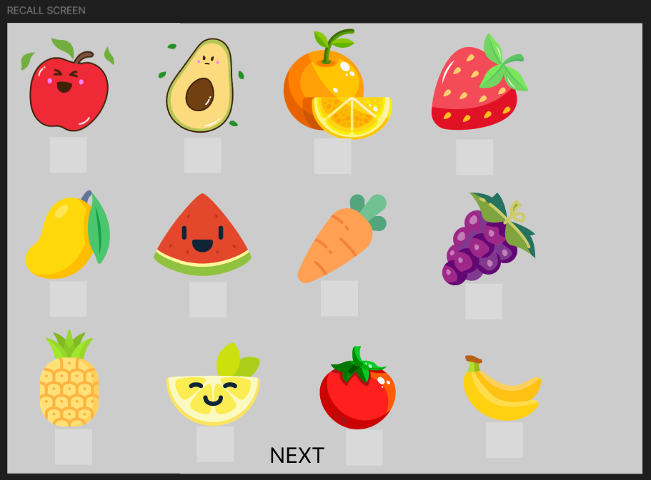
Recall Screen:
The recall screen allows users to identify the items they remember from the chunking phase.
Features
• Displays a grid of multiple icons.
• Users must select the icons they remember seeing.
• Selected items are categorized as: o Correct selections o Incorrect selections
• A Submit button is provided to finalize the user's recall choices.
Purpose
This screen measures the user's ability to recall visual elements after viewing chunked information.

- Result Screen
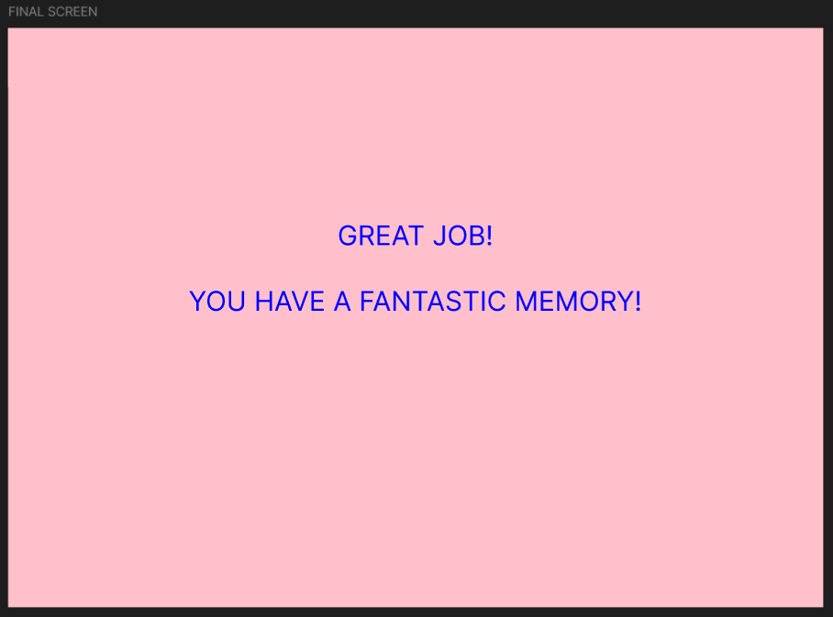
Result Screen:
The result screen displays the user's performance after submitting their recall.
Features
• Shows the total score (for example 12/15 items recalled correctly).
• Displays a performance breakdown including:
o Correct answers
o Incorrect answers
o Overall accuracy percentage
• Provides feedback such as “Excellent Memory!”
• Includes buttons for:
o Try Again
o Back to Home
Purpose
This screen provides feedback and allows users to evaluate their memory performance. Advantages of Chunking in UI Design
• Improves memory retention
• Makes information easier to process
• Reduces cognitive load
• Enhances user experience and usability
• Helps users recall information faster
Result
The UI design demonstrates how chunking helps users recall visual information more effectively. By grouping related icons together, users can remember more items compared to unstructured visual layouts.

